Specification document for **LockedMe.com** application

This is a File Management prototype application with listing, adding, deleting and searching functionalities on behalf of Lockers Pvt. LTD.

Developer: Laios Giannis – [laiosgiannis@gmail.com](mailto:laiosgiannis@gmail.com) // ioannis.laios@vodafone.com

The project will be separated in 3 weekly sprints:

1. Setting up the plan of what OOPs concepts are going to be used for the application
2. Write the code in different parts and packages and push it to GitHub
3. Test the code to ensure that it works as expected and brainstorm future changes and enhancement.

OOPs concepts used

**Classes, methods and objects** were created in order to deal with the user interaction with the program and also provide its functionalities. FileManagement class along with methods like MainMenu, SubMenu, listFilesAscending and Collections.sort help to have a functional application. Finally, scanner object helps us with the user interaction and fileList object to manage the files.

**Abstraction** used to create a better understandable structure of code separated in different packages and method usage in the main code where needed.

**Encapsulation** within the methods to hide the menu functionality and file management.

**Exception Handling** with try-catch to deal with mistaken error inputs and maintain the continuation of the application while moving to the main menu and the submenu.

**LinkedList** is used to list the files and be the base for adding, deleting, searching and sorting functions.

**Git Details**

GitHub link: <https://github.com/glaios/LockedMe.com.git>

staclos@staclos-PC MINGW64 ~/eclipse-workspace/LockedMe.com

$ git status

fatal: not a git repository (or any of the parent directories): .git

staclos@staclos-PC MINGW64 ~/eclipse-workspace/LockedMe.com

$ git init

Initialized empty Git repository in C:/Users/staclos/eclipse-workspace/LockedMe.com/.git/

staclos@staclos-PC MINGW64 ~/eclipse-workspace/LockedMe.com (master)

$ ls -a

./ ../ .classpath .git/ .project .settings/ bin/ src/

staclos@staclos-PC MINGW64 ~/eclipse-workspace/LockedMe.com (master)

$ git status

On branch master

No commits yet

Untracked files:

(use "git add <file>..." to include in what will be committed)

.classpath

.project

.settings/

bin/

src/

nothing added to commit but untracked files present (use "git add" to track)

staclos@staclos-PC MINGW64 ~/eclipse-workspace/LockedMe.com (master)

$ git branch

staclos@staclos-PC MINGW64 ~/eclipse-workspace/LockedMe.com (master)

$ git branch -M main

staclos@staclos-PC MINGW64 ~/eclipse-workspace/LockedMe.com (main)

$ git branch

staclos@staclos-PC MINGW64 ~/eclipse-workspace/LockedMe.com (main)

$ git status

On branch main

No commits yet

Untracked files:

(use "git add <file>..." to include in what will be committed)

.classpath

.project

.settings/

bin/

src/

nothing added to commit but untracked files present (use "git add" to track)

staclos@staclos-PC MINGW64 ~/eclipse-workspace/LockedMe.com (main)

$

staclos@staclos-PC MINGW64 ~/eclipse-workspace/LockedMe.com (main)

$ git add .

staclos@staclos-PC MINGW64 ~/eclipse-workspace/LockedMe.com (main)

$ git status

On branch main

No commits yet

Changes to be committed:

(use "git rm --cached <file>..." to unstage)

new file: .classpath

new file: .project

new file: .settings/org.eclipse.core.resources.prefs

new file: .settings/org.eclipse.jdt.core.prefs

new file: bin/locked/me/com/app/FileManagementApp.class

new file: bin/locked/me/com/mainmenu/MainMenu.class

new file: bin/locked/me/com/submenu/SubMenu.class

new file: bin/module-info.class

new file: src/locked/me/com/app/FileManagementApp.java

new file: src/locked/me/com/mainmenu/MainMenu.java

new file: src/locked/me/com/submenu/SubMenu.java

new file: src/module-info.java

staclos@staclos-PC MINGW64 ~/eclipse-workspace/LockedMe.com (main)

staclos@staclos-PC MINGW64 ~/eclipse-workspace/LockedMe.com (main)

$ git commit -m "LockedMe.com first version"

[main (root-commit) 5592ce3] LockedMe.com first version

12 files changed, 227 insertions(+)

create mode 100644 .classpath

create mode 100644 .project

create mode 100644 .settings/org.eclipse.core.resources.prefs

create mode 100644 .settings/org.eclipse.jdt.core.prefs

create mode 100644 bin/locked/me/com/app/FileManagementApp.class

create mode 100644 bin/locked/me/com/mainmenu/MainMenu.class

create mode 100644 bin/locked/me/com/submenu/SubMenu.class

create mode 100644 bin/module-info.class

create mode 100644 src/locked/me/com/app/FileManagementApp.java

create mode 100644 src/locked/me/com/mainmenu/MainMenu.java

create mode 100644 src/locked/me/com/submenu/SubMenu.java

create mode 100644 src/module-info.java

staclos@staclos-PC MINGW64 ~/eclipse-workspace/LockedMe.com (main)

$

staclos@staclos-PC MINGW64 ~/eclipse-workspace/LockedMe.com (main)

$ git config --global user.email laiosgiannis@gmail.com

staclos@staclos-PC MINGW64 ~/eclipse-workspace/LockedMe.com (main)

$ git config --global user.name "Laios Giannis"

staclos@staclos-PC MINGW64 ~/eclipse-workspace/LockedMe.com (main)

$ git status

On branch main

nothing to commit, working tree clean

staclos@staclos-PC MINGW64 ~/eclipse-workspace/LockedMe.com (main)

$

staclos@staclos-PC MINGW64 ~/eclipse-workspace/LockedMe.com (main)

$ git remote add origin https://"***mytoken***"@github.com/glaios/LockedMe.com.git

staclos@staclos-PC MINGW64 ~/eclipse-workspace/LockedMe.com (main)

$ git push -u origin main

Enumerating objects: 29, done.

Counting objects: 100% (29/29), done.

Delta compression using up to 4 threads

Compressing objects: 100% (21/21), done.

Writing objects: 100% (29/29), 7.14 KiB | 1.19 MiB/s, done.

Total 29 (delta 0), reused 0 (delta 0), pack-reused 0

To https://github.com/glaios/LockedMe.com.git

* [new branch] main -> main

branch 'main' set up to track 'origin/main'.

staclos@staclos-PC MINGW64 ~/eclipse-workspace/LockedMe.com (main)

$

**App Functionality**

Empty list

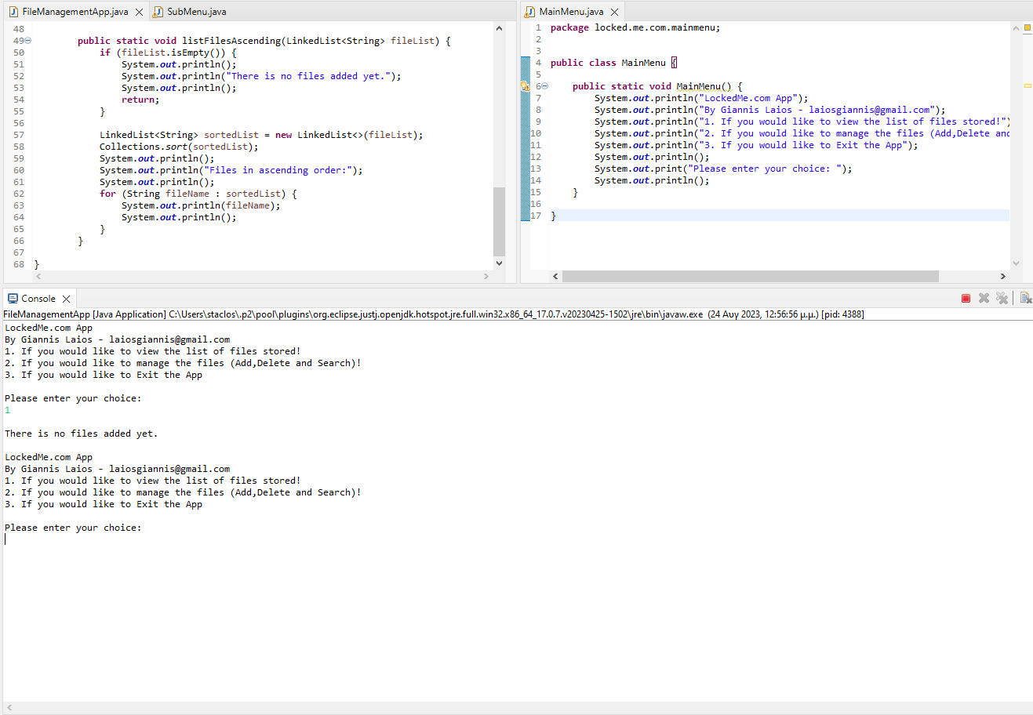

Exiting App

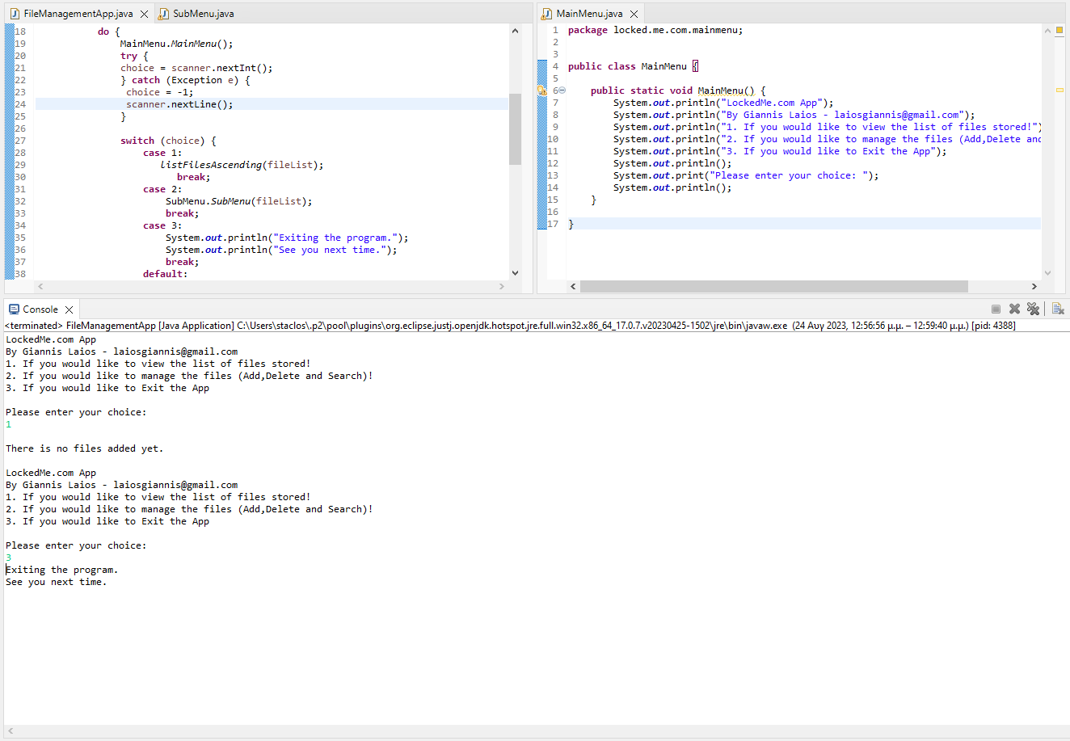

File Manager

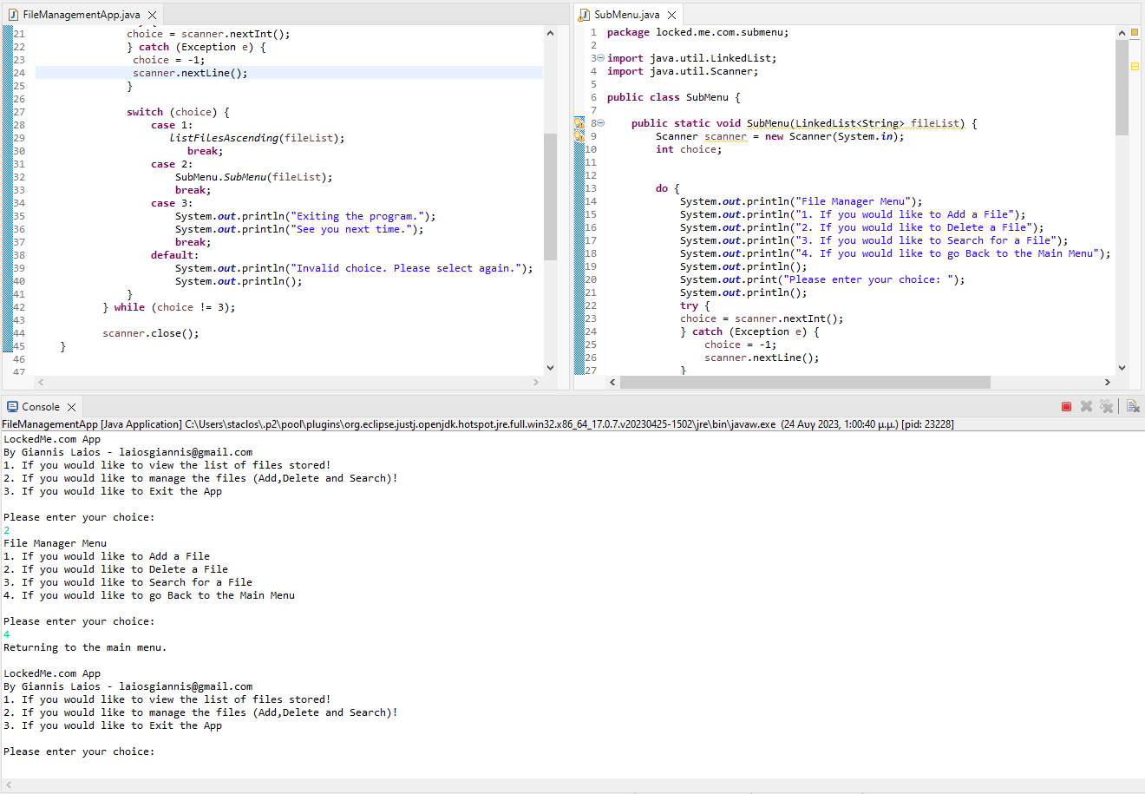

Return to main menu

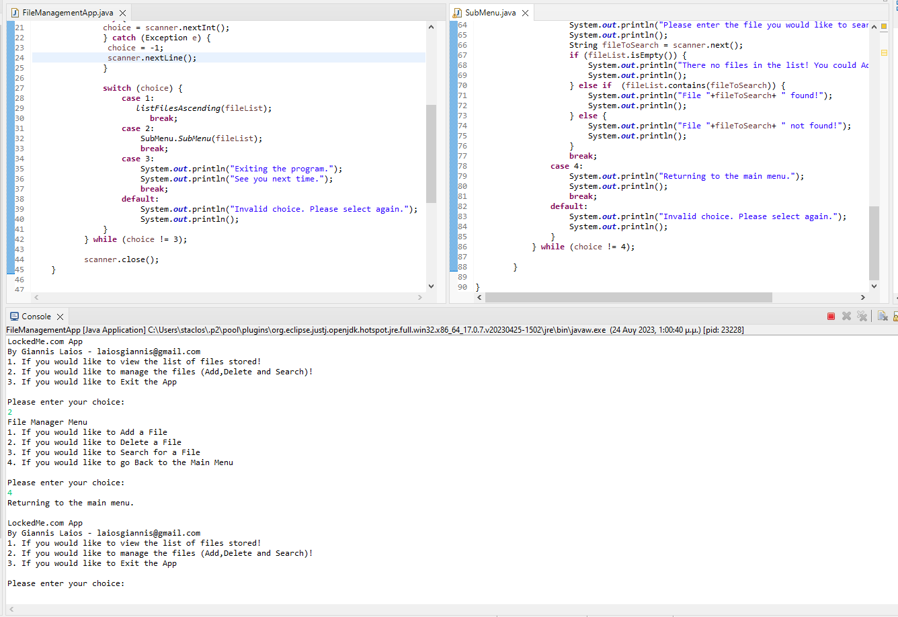

No exception throwing no App terminating

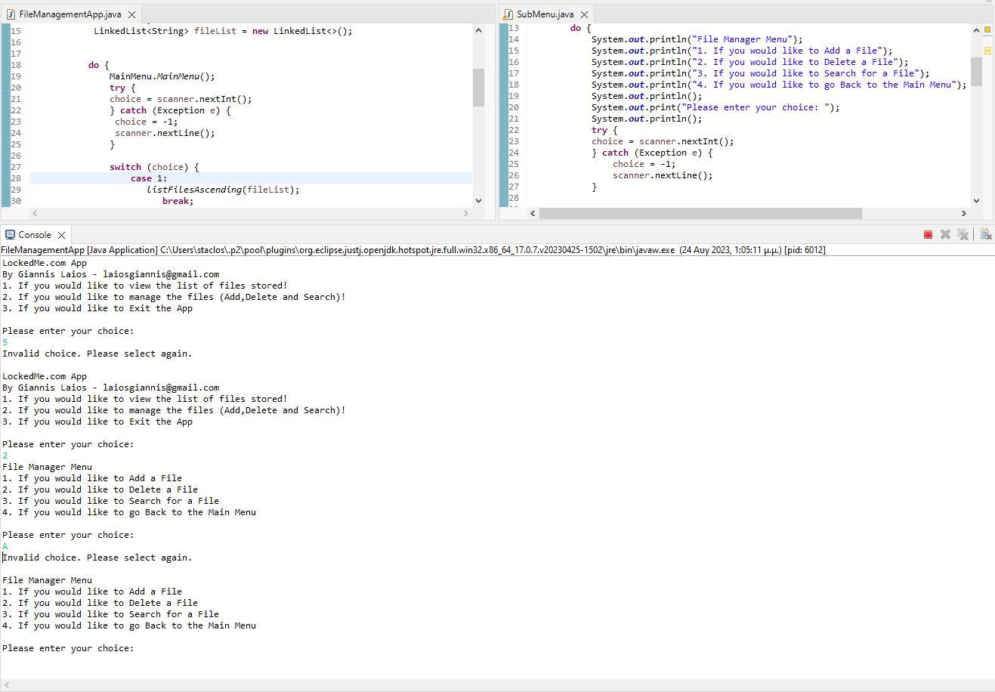

Adding files

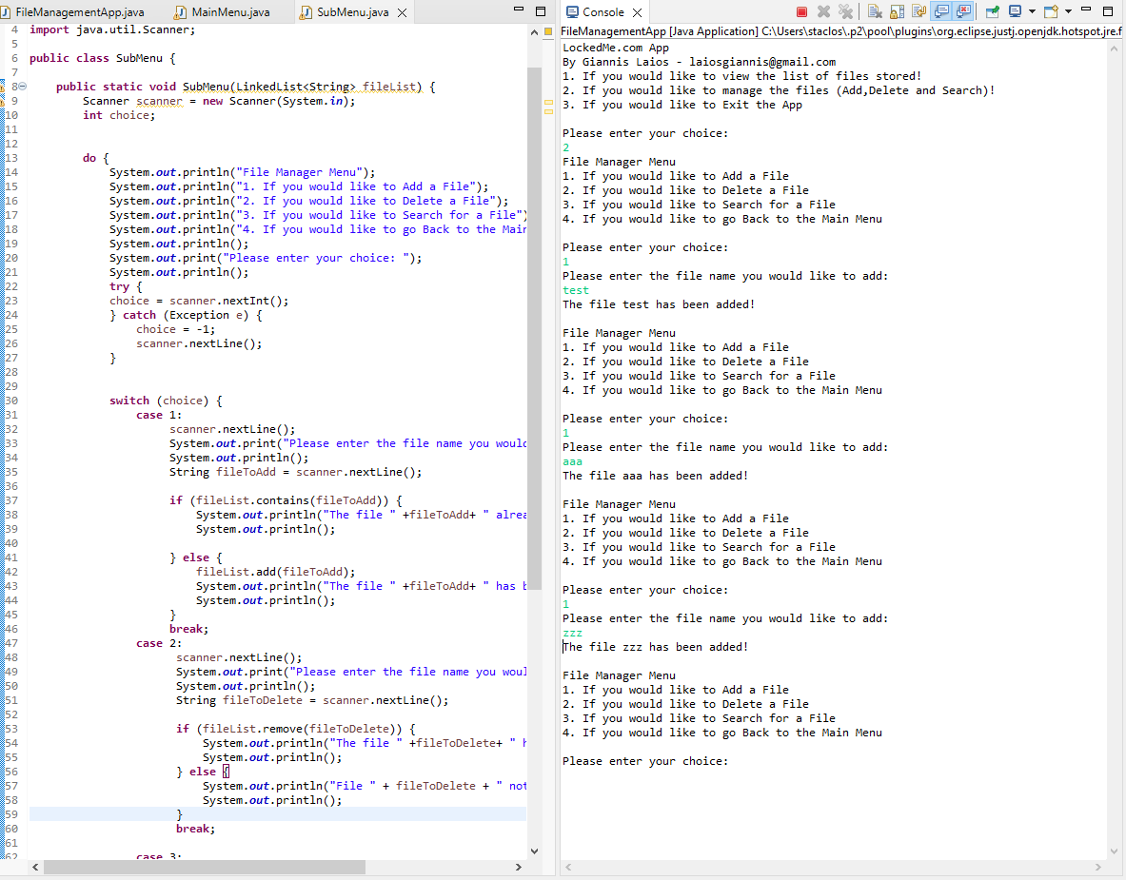

Listing in Ascending Order

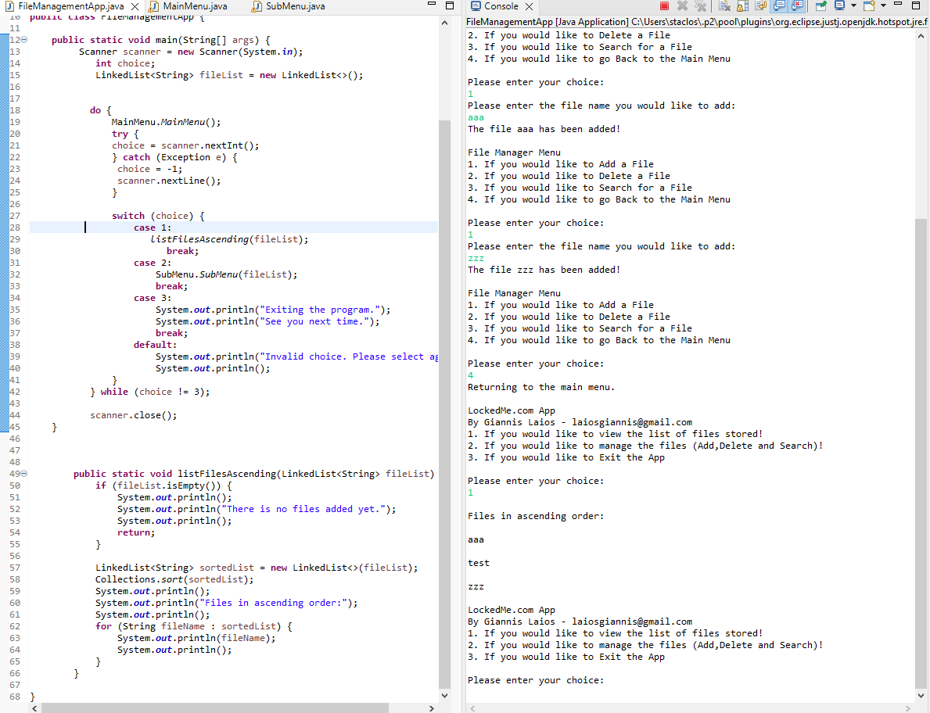

Searching and Deleting existing and non existing files

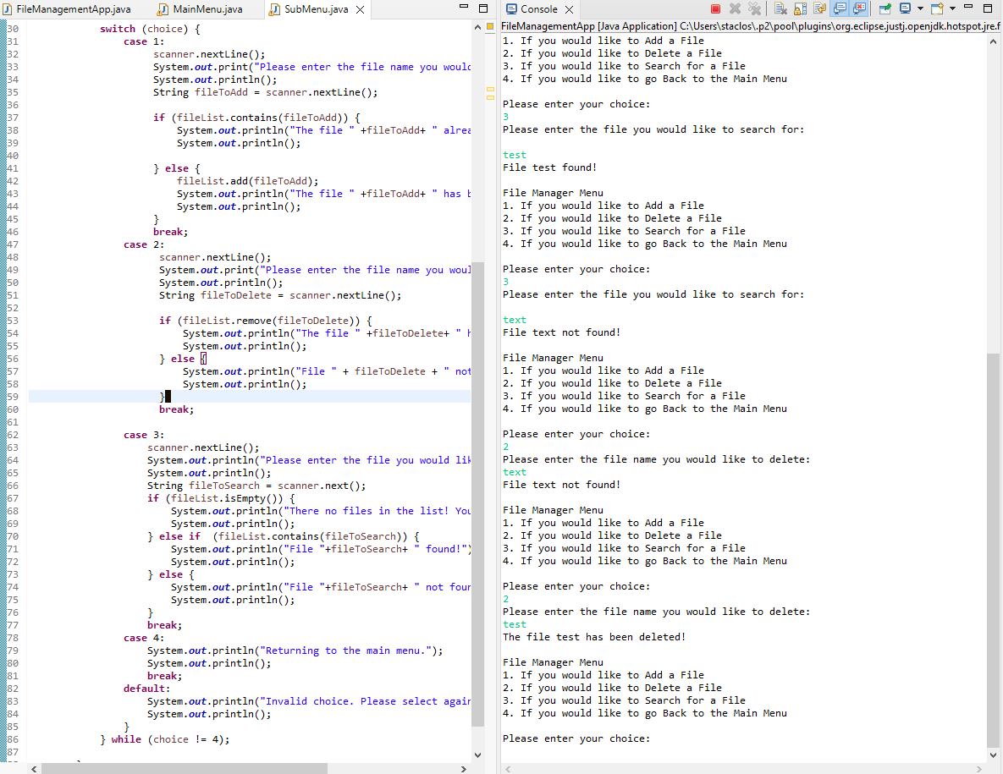

Sorting without the deleted file

